TITLE of paper
(ARIAL, 14 pt, all caps)

A.B. AUTHOR, C.D. AUTHOR (12 pt, all caps)
Department, Organisation (10 pt, italics)
Street, Postal Code City – Country (10 pt, italics)

E.F. AUTHOR
Other department, Other organisation (10 pt, italics)
Street, Postal Code City – Country (10 pt, italics)

ABSTRACT

Your manuscript must be in English. Please use UK spelling. It should start with a short abstract of 150 words maximum describing the key elements of your contribution and its conclusions. The text should be typeset in block mode. Typeface throughout the text is Arial. For this paragraph the font size is 10 pt, with left and right indents of 1.5 cm.

- Introduction (12 pt, bold)
- Settings
Your manuscript should then continue on the same page with an introduction. The typeface throughout the text is Arial. Setting of paper size is DINA4-size only. The top, left and right margins are 2.5 cm while the bottom margin is 2 cm. For all following text sections the font size is 11 pt, single line spacing with a spacing of 0 pt before and after the paragraph mark, and the lines are justified in block mode.

- Figures and tables

Figures and tables should be inserted into the text at the appropriate place. They should be clearly identified with a caption, as shown below.

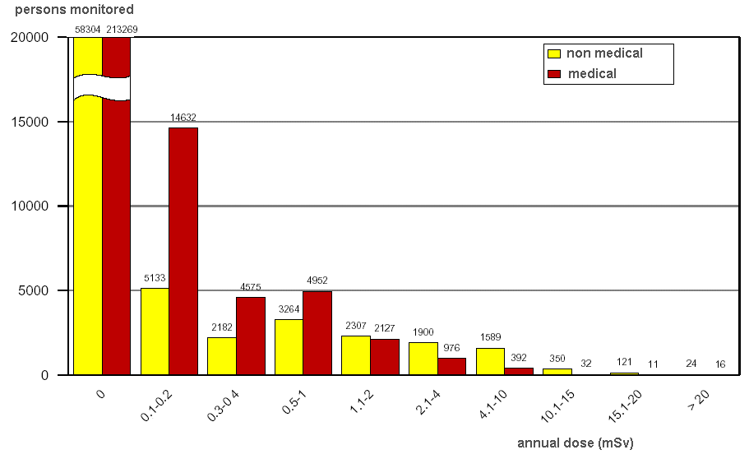
Fig 1. Caption for figure one

xxx | yyy | zzz
aaa | 123 | 456
bbb | 789 | 012
ccc | 345 | 678
ddd | 901 | 234
Tab 1: Caption for table one

- Electronic form of contribution

For the conference proceedings (Transactions) an electronic version as a MS WORD.doc file of your final paper is required together with an ADOBE Acrobat .pdf version (the latest will allow checking the documents (and in particular graphics) are not distorted). Please use UK spelling.

- Length of your presentation

We recommend limiting your paper to five to ten pages, including the title page, all tables and figures and the references.

Your powerpoint presentation will be (exclusively) in English and not last more than 20 minutes.

- Visual aids for oral presentations, special instructions for poster presentations

The visual aid available to you as a speaker in an oral session is PowerPoint projection.

Posters will be on display at dedicated moments of the conferences. The Poster should be printed on A0 format (841 x 1189 mm or 33.13″ x 46.84″). At least one author per paper is requested to attend personally the poster session.

- References

Please number your references and cite them in brackets. The list of references should be at the very end of your manuscript under the section heading “References”.

- Deadline
Your full paper must be submitted by 15 February 2019 at the very latest.

Your CV must be in our possession by 15 April 2019 and Powerpoint presentation by 15 May 2019 and at the very latest.

- Registration

For each paper (oral or poster presentation) one author needs to be identified as presenter, register through the FISA 2019 EURADWASTE ‘19 Online Registration System and attend the conference.

